**Practical no:1**

Aim:To study and execute basic Linux System Commands.

Linux Commands:

Directory Commands – pwd, mkdir, cd, ls, rmdir

File Commands - cat, touch, cp, rm, mv

File Information Display Commands - top, head, tail,

sort, grep

System Commands - whoami, which, clear, history, man

**NAME : Maithili Lokhande**

**BATCH : B1**

1. pwd

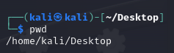

1. mkdir

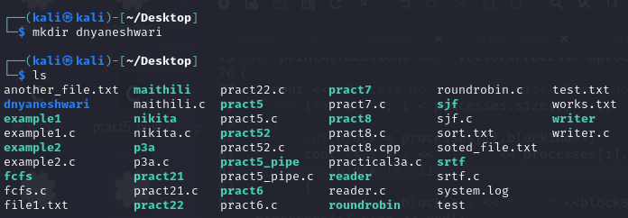

1. rmdir

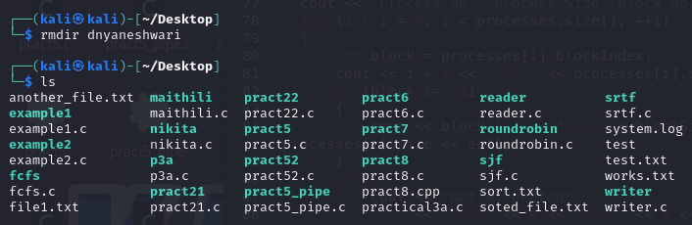

4, touch

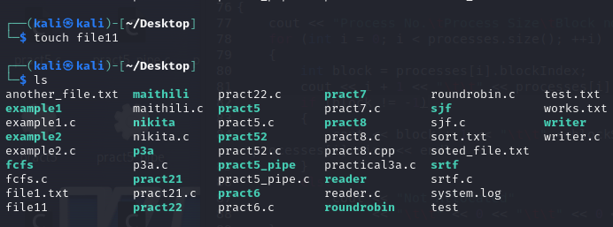

1. cat

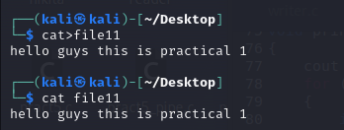

1. rm 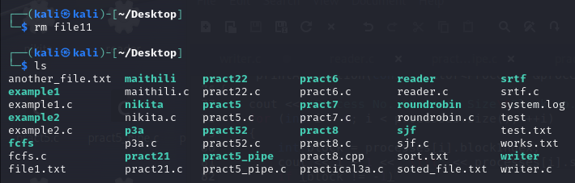
2. whoami



1. which

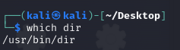

1. history

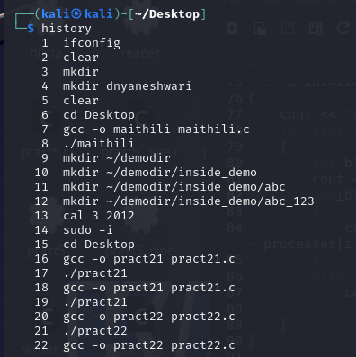

1. head, tail

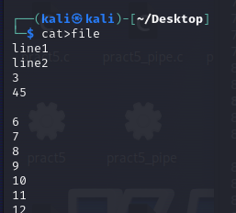

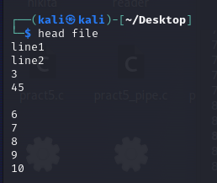

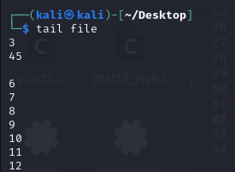

1. grep

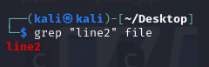

**PRACTICAL NO: 2**

Aim To write and execute I/O system calls in Linux.

I/O System Calls: open, close, read, write, creat, unlink,

umask, chmod, lseek, link, system

System Flags : O_CREAT, O_WRONLY,O_RDONLY, O_TRUNC

Mode Bits: S_IRUSR , S_IWUSR , S_IRGRP , S_IROTH, ..

**Name : Maithili Lokhande**

**Roll no. : 07**

**Batch : B1**

**WRITE:**

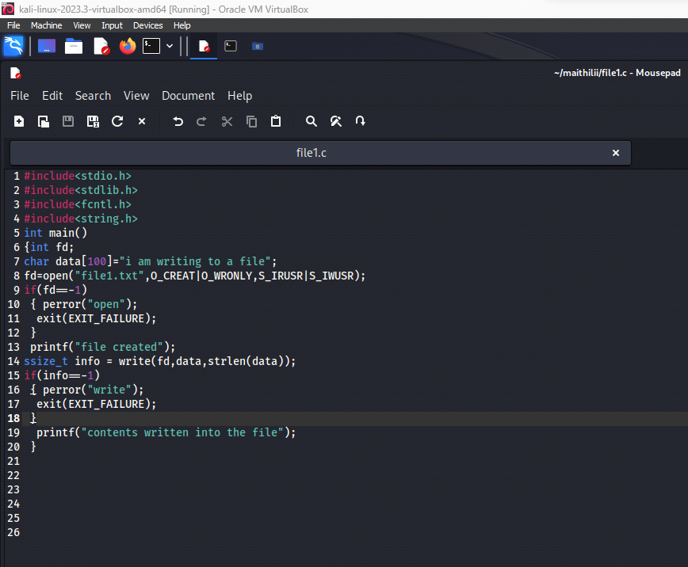

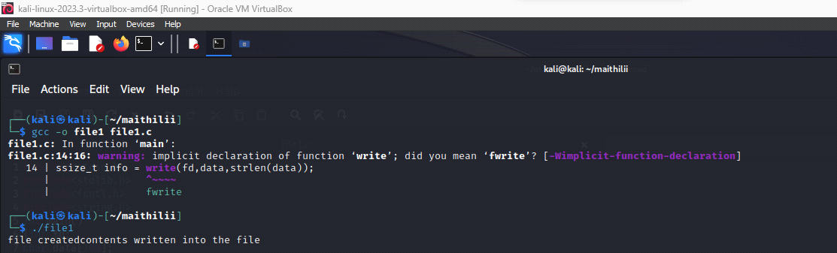

**READ:**

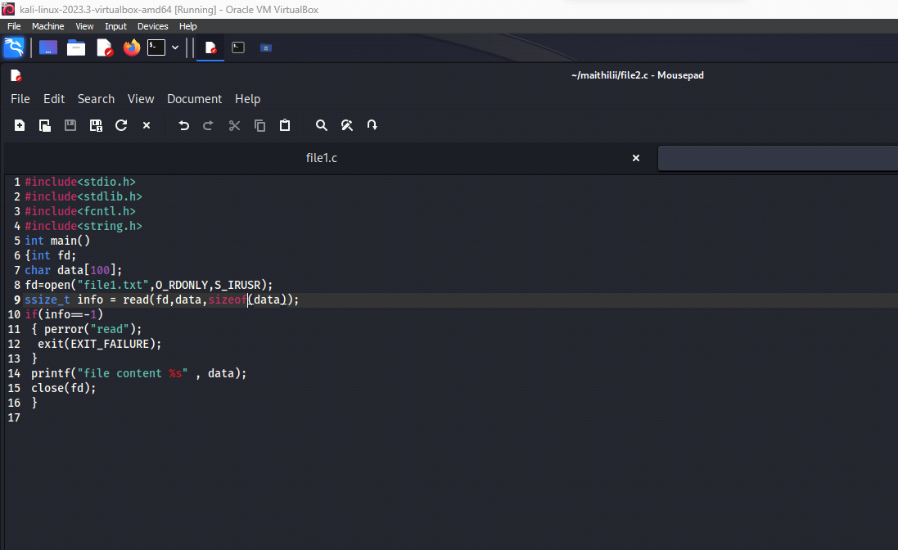

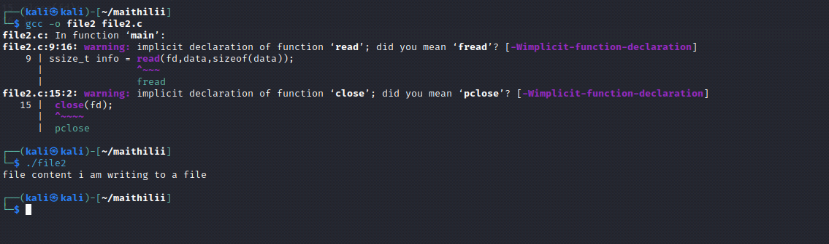

**PRACTICAL no: 3**

Aim: Write and execute programs to implement the process control system calls.

Process Commands: fork, exec family (execl, execlp, execv,

execvp, execle, execve), getpid, getppid, wait, sleep, exit, _exit

**Name : Maithili Lokhande**

**Roll no. : 07**

**Batch : B1**

P3a.c code:

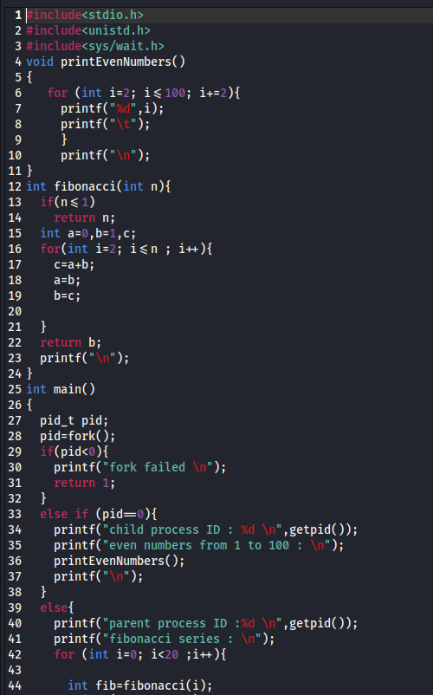

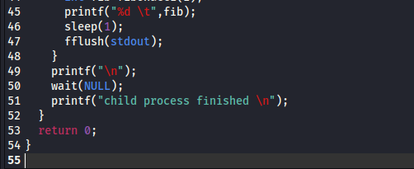

Output :

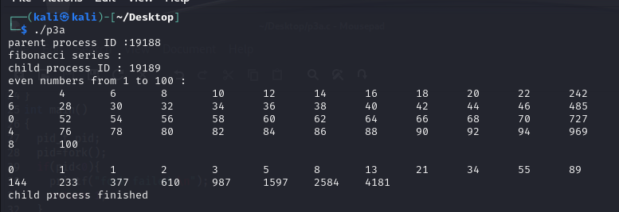

---------------------------------------------------------------------------------------------------------------------------------------------------------------

3b.c

Code1:

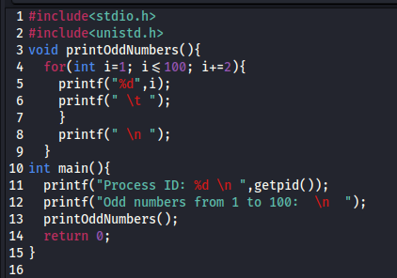

Code2:

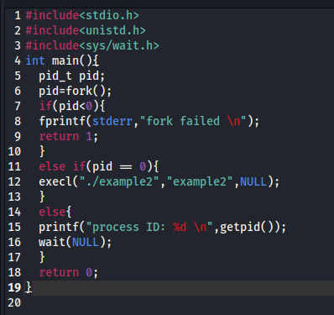

Output :

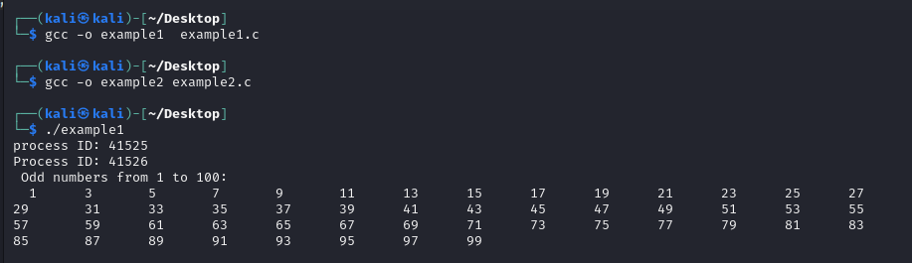

**PRACTICAL no: 4**

Aim: Write and execute programs to demonstrate different CPU

scheduling algorithms.

CPU Scheduling: Preemptive & Non-preemptive scheduling, FCFS, SJF, Round Robin, Shortest Remaining Time First

**Name : Maithili Lokhande**

**Roll no. : 07**

**Batch : B1**

**Fcfs**

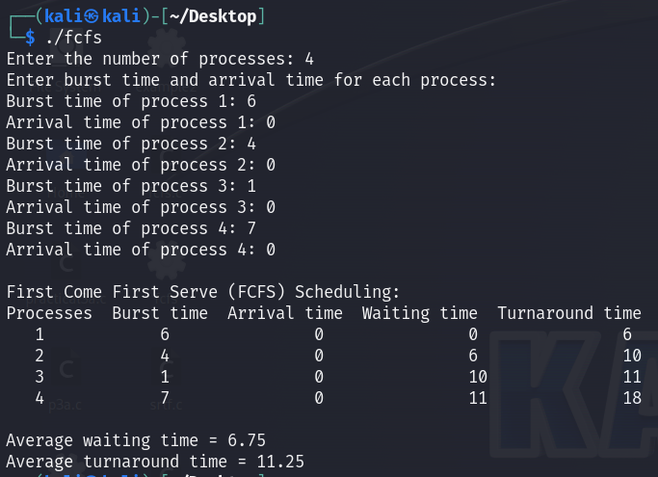

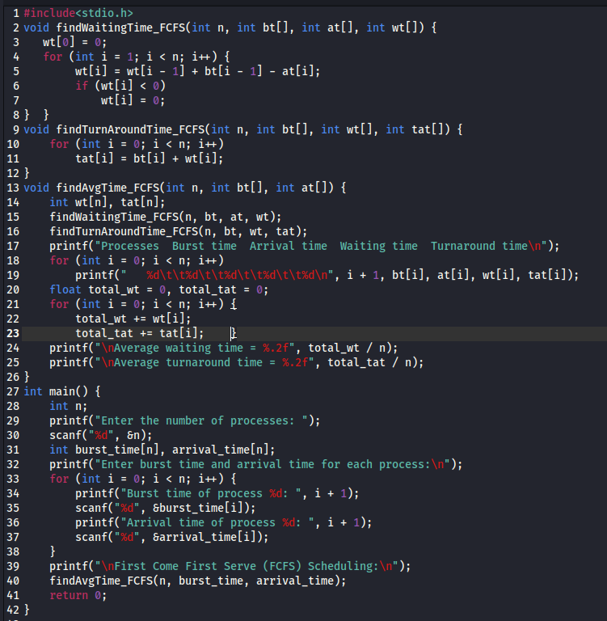

**Sjf**

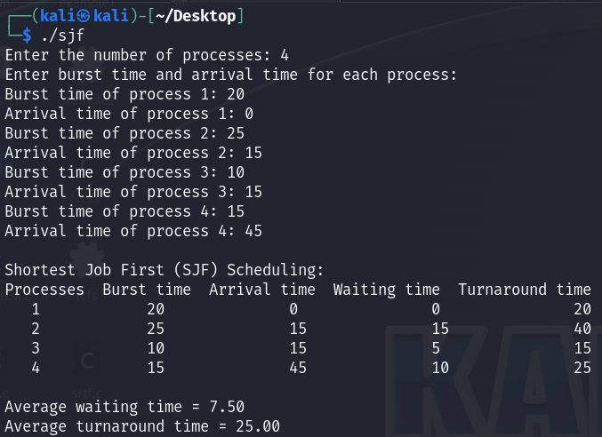

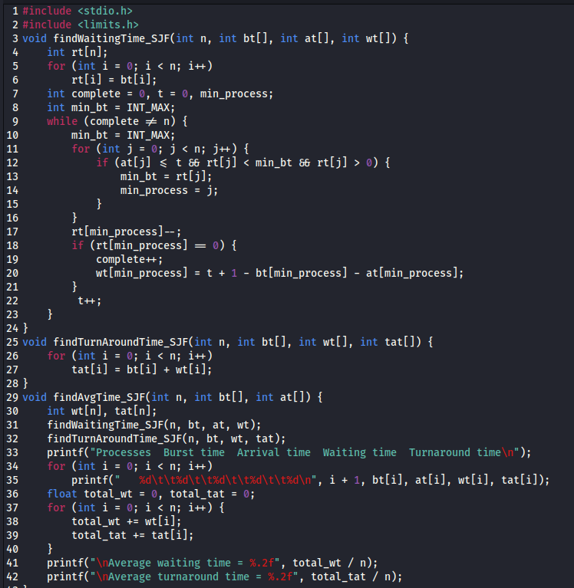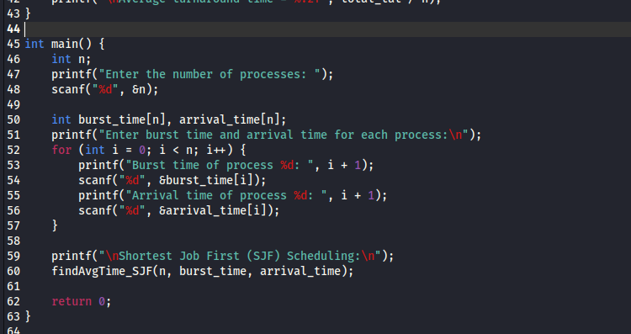

**Srtf**

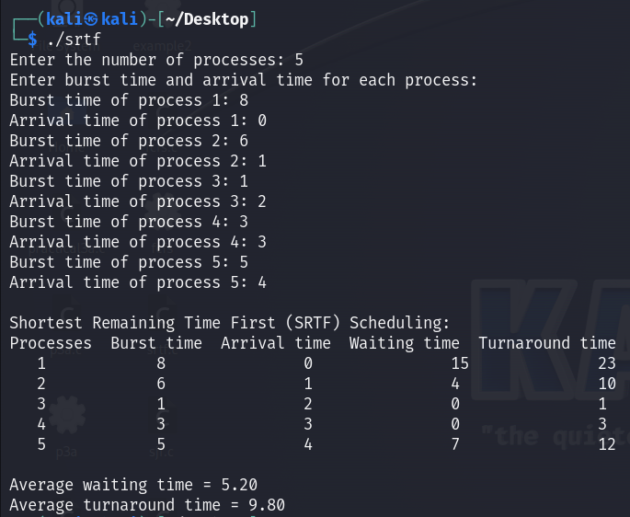

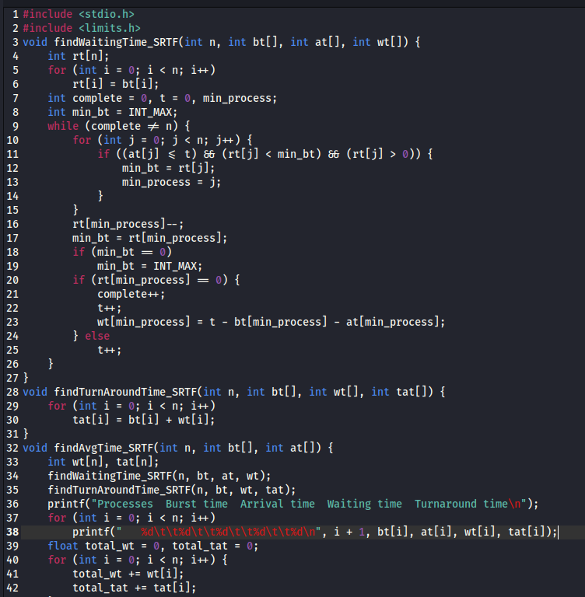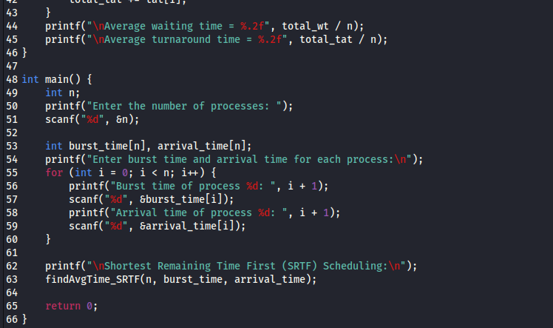

**Round-robin**

